

Introduction

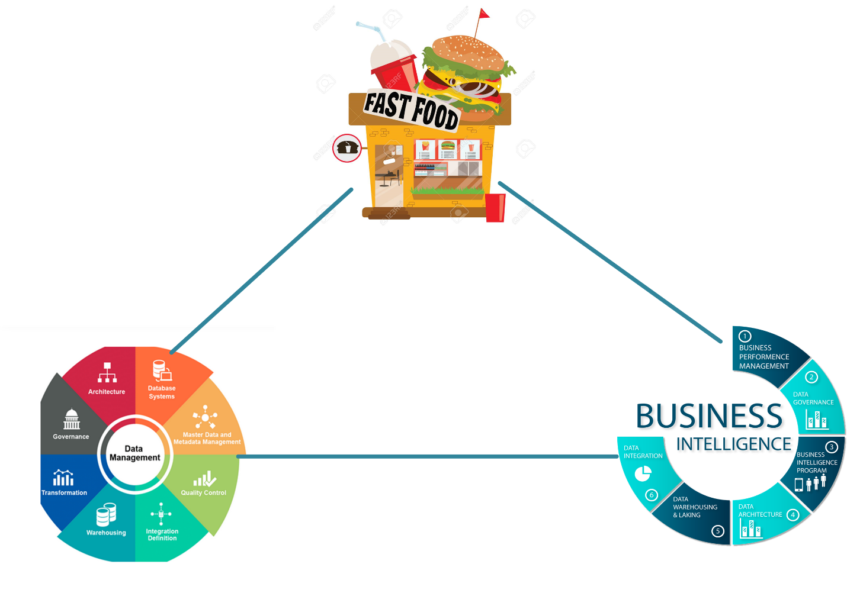

Nowadays, technology is used in almost every field from creating artificial intelligence to uplifting of business. Technology can be used in any field to uplift their respective business. One of the filed where technology is most used is business. Now days almost each and every organization used database technology and decision support system. For taking maximum advantage from business and know strength, weakness of organization. The database is collection of information. In the database insert, update, select, delete use SQL query. Before database technology introduces in business there is traditional method is used for data collection such as excel, paper. Storing data in these excel and paper was problem is cannot get right information fast. if right information cannot get as much as fast then business can face some loss in business. Business must need right information fast as soon as possible. Solving this similar problem database technology is introduced in business. This is modern technology area. In this modern era data is most valuable asset for any organization. that reason data is called modern revenue. Data are dumb and don’t have any value unless right use of it. At first phase storage costly. Nowadays storage comes with lower cost and performance is important. The database can store large amount of data and can retrieve right information use different tools and technology.

Before visualization technology introduces in the business most organization can correct knowledge about their business. They cannot easily take decision about organization. Nowadays visualization is used everywhere for fast decision making. Visualization present information in most effective and efficient way that anyone can easily understand. Visualization play most important role in business. Use of visualization organization can know sales trend, which type customer they have, which is most profit month, year and which is not, strength and weakness of organization.

Fast-food restaurant business store day by data. for business growth and successful organization need most effective data management plan and Visualization. If organization cannot make effective data management plan, then database system cannot perform at peak level, cannot get right information fast. For performing better and peak level, faster get right information data management plan need. For data management plan oracle technology is implemented. Oracle technology use different technique which enhances the system performance and get right information fast as soon as possible. Visualization makes the decision support system which helps to take decision easily favor of organization. Visualization even can predict the future use of past data. Such as in past march is most profitable month and some particular product is sold. If organization know this information, then they can ready or prepare for the march month and which product most sell. Aim of this project is implemented oracle technology and make decision support system.

Database Architecture:

The database is a collection of information where data is managing. In database DML operations are done. For supporting DML operations different hardware and software perform. Without these hardware and software component database even cannot start. Given below is the graphic diagram of database.

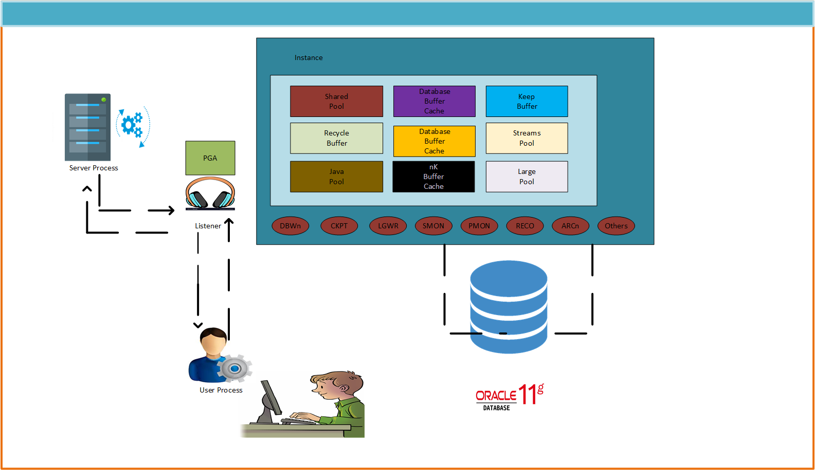

These are some component which helps to run the database.

Shred Pool: - It is a database data dictionary. This dictionary has complete information about the database.

Large Pool: - it handles space matter. In the database different tasks are done. Some task needs huge space and resource. This pool handle provides space and resource.

Database Buffer cache: - It main task is to hold the data.

Redo log: - Redo log handle the DML operations.

Java Pool: - it handles all java related execution and activity. Such as database creation.

Streams Pool: - Maintain channel.

**Connection to server**

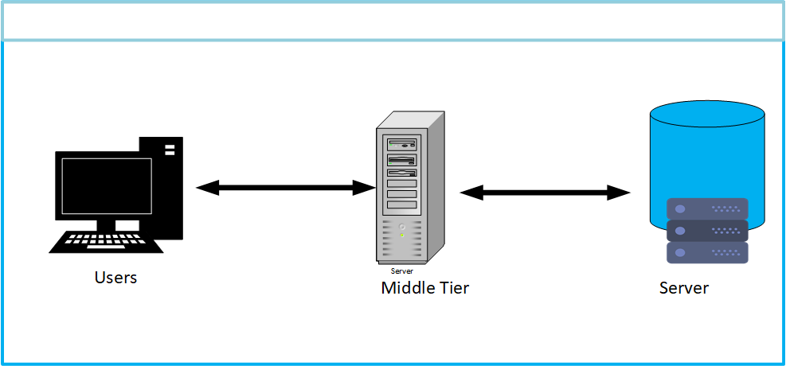

Consider a given scenario there is user server and database. At first user enter username and password. If enter information is right, then user can access the system or physical data else cannot access the system.

**Database storage**

**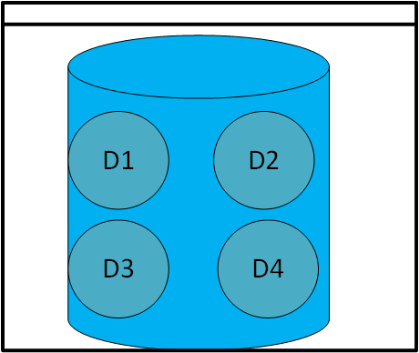**

Database size depends on the business need.**Fastfood restaurant** database size is 30GB. You can add storage space in the future if required for the system. For storage increase disk can be added. These disk increase the storage of database.

**Installation**

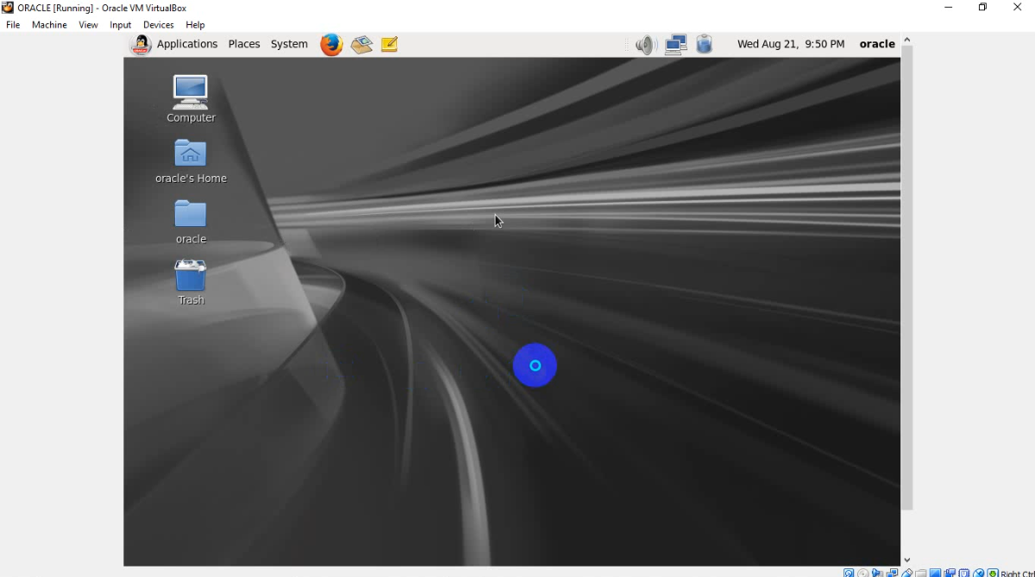

Linux is open source. It is operating system. it is different than the window. Linux are different types such as oracle, kali, Ubuntu etc. All these Linux use similar types of commands for system.

For installing oracle database oracle Linux is used. Most of Linux are unstable due to lots of update. Some Linux need daily update. Database is most sensitive part of organization because it has all organization data. if daily update need then system may be slow or files may be manipulating. Other Linux cannot guaranty of data due to open source. In this case oracle Linux is stable and need update fix time period, guaranty oracle data safety. Oracle Linux have all feature this reason oracle server is install in oracle Linux.

**System requirement**

RAM: - Installing oracle database at least 4 GB ram needed.

Storage: - Storage depend on the business need. For this project Dynamic 120 GB storage allocate. Storage is 120 GB but it only consumes storage how much needed.

Boot: - it is small partition and participate at start. It need small space. For this project it has 200 MB storage is given.

/(root): - it is top level directories. All other oracle partition mounted on subdirectories of the root partition. For this project 20 GB storage space is given.

/u01: - it is oracle portion where all oracle data are stored. it has given 15 GB storage space.

/home: - this partition is used for Desktop directory of Linux users accounts. For this project it has given 15 GB storage space.

/tmp: - it is used for temporary files. During oracle installation process oracle need huge storage for installation. At this time, it provides temporary storage for installation. For this project it has given 15 GB storage space.

SWAP: - Some time at work ram has not enough space at this point task are stop. For this solution temporary space is allocate in hard disk which provide temporary space for task complete. It must be 1.5 0times size of RAM. For this project 4GB RAM is allocate so SWAP size is 6 GB.

Installation process is given below.

|  |  |  |
| --- | --- | --- |
|  |  |  |
|  |  |  |
| For this project default name is select but there is name can be select if you need different name. |  | There is default root user is available. You can customize the password of root user. For this project root password is password. |

|  |  |  |
| --- | --- | --- |
|  | For partion and adding storage different directory at first click on create button. | Select standard partition then click next. |
| Select directory and add storage what business need then click create |  | Creating SWAP partion. |
| When required partition are created then click next. | Click format button. | clcik on write changes to disks. |

|  |  |  |
| --- | --- | --- |
|  |  |  |
|  |  |  |
|  |  |  |

|  |  |  |
| --- | --- | --- |
|  |  |  |
|  |  |  |
|  |

**Troubleshoot**

When Linux installation is complete at first computer cannot get IP address. Which is given below.

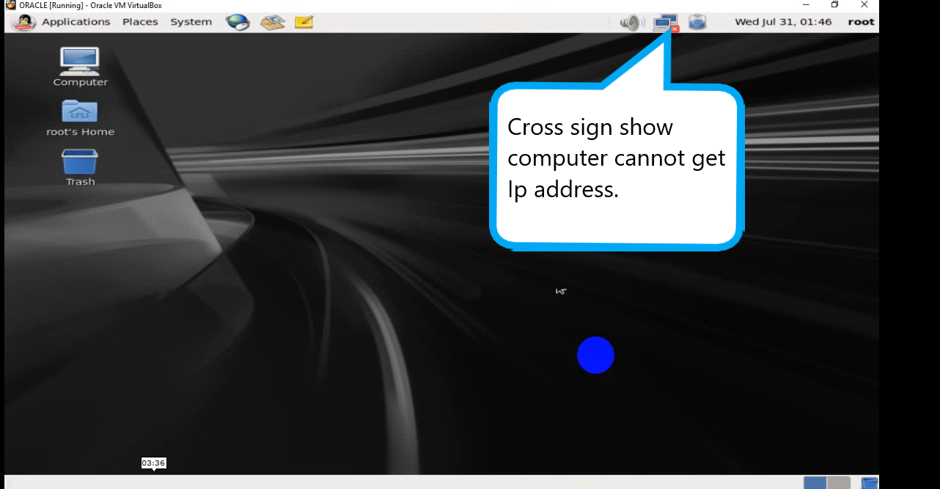

**Solution**

|  |  |  |
| --- | --- | --- |
| Power Off the Linux | Go to setting. | Click on network |
| Click on adapter 2 | Enable the option and chose Host only adapter then click ok. Then start the Linux u got IP address. For IP check in Linux open terminal then type ifconfig then u got IP address. | If ok option is unavailable, then go to host network manager. |
| Remove available adapter. | Create new network adapter. Click on new then it asks permission click yes. | Enable the option |
| **D:\document_video\installation\screenshot_project\11.png**  Again go to setting and click on network and go to adapter 2. Enable option chose host only adapter then this time ok option is available then click on ok. Start the Linux. |  | Check IP address of server. Open terminal type ifconfig. |
|  |

Yum configuration

Oracle is most sensate part of organization this is the main reason yum configure needed. yum configure all grid and oracle required packages. It is also called file protocol of server.

|  |
| --- |
| At first select om device and select the Linux ISO file. If ISO file is not shown then go ISO file location and select the file. |
| After select the ISO file create the directory where all files can be copy. Copy all the files from ISO to Linux. When all files are copy then check the packages. |

Trouble shoot

After complete copy from ISO file to device eject the ISO file. If is file is not ejecting, then reboot the computer for permanent file changes. There is one serious problem is introduced which is system show you have to re-install the Linux again. Before you reboot the computer you must be eject the ISO file.

|  |
| --- |
|  |

|  |
| --- |
| Creating required repository. |

|  |
| --- |
| Managing all packages. |

|  |
| --- |
| After packages manage then check the yum repos. If repo is public, then remove public repo use following command. After remove public repo create file where server can be set up. For server set vi packages file is create. |

|  |
| --- |
| If you have all this text file copy, then paste in the create vi file. If you don’t have file, then write in the file. This is server set. All oracle files are install from this server. |

|  |
| --- |
| Check weather server set up successful or not. For this purpose, install Firefox. Firefox is install successfully then server set up successful else not. |

|  |
| --- |
| Firefox install successful. |

|  |
| --- |
| Oracle need packages for install. Above all define text are oracle packages. Copy all text and paste. |

|  |
| --- |
|  |

|  |
| --- |
| Defining system required minimum and maximum size for Linux. Use given command open the file then paste text. |

|  |
| --- |
| Make file and paste the grid and oracle packages. |

|  |
| --- |
| Oracle is third party software for red hat Linux. This reason if firewall is enable then firewall cannot give permission to install the oracle. For disable install oracle and disable the firewall using given command. |

|  |
| --- |
| Disable the firewall different ways. |

|  |
| --- |
| Disable the firewall and managing the IP table. Finalize the configuration for permanent changes. |

|  |
| --- |
| Creating grid and oracle group. Create grid, oracle user and set up password. Password can be customizing here grid and oracle. You can put grid and oracle password whatever you want. |

|  |
| --- |
| Oracle database is not install like Microsoft window system. Oracle database need specific directory for installation. Given picture directory is created for oracle and grid. |

|  |
| --- |
| Set up oracle environment. For set up oracle environment change user to oracle then create file. After creating file copy paste the text then save and exit. |

|  |
| --- |
| Set up grid environment. At first change user to grid then create file. creating file copy paste the text then save and exit. |

|  |
| --- |
| Check the directory human understandable form. |

|  |
| --- |
| For database installation storage is need. For storage disks are added. Each and every disks are must be same size. All disks contain same amount of data. All data are equally distributed in disks. At first enter the command for disk create then enter p for check how many disk is available. For new disk create enter n which allow you to create new disk. Disk cylinder number must be start where last cylinder number ended. Which is shown above figure. For this project 5 disks are created with each have 5 GB storage. |
| After creating disks enter the command W which exit from the disk create location. After successful disk creation reboot the server for permanent changes. |

|  |
| --- |
| For database installation you must have three file. For my project I copy and paste in Linux desktop. |

|  |
| --- |
| D:\document_video\installation\oracle image\k12.png  Install the files step by step. |

|  |
| --- |
| Tagging disks for oracle and reboot the computer for permanent changes. |